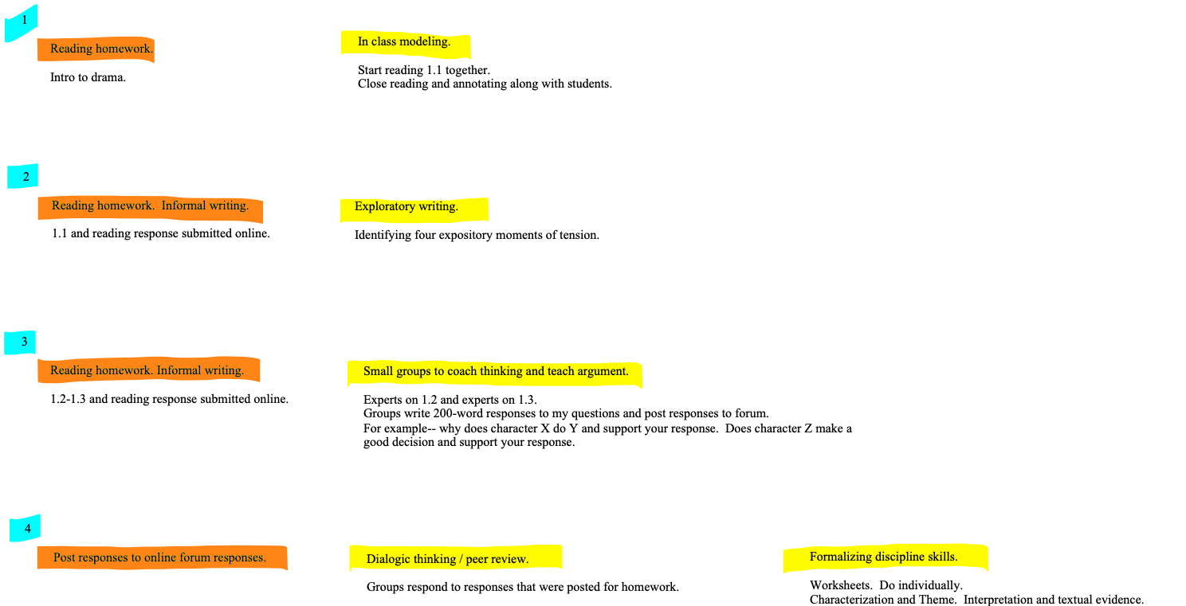
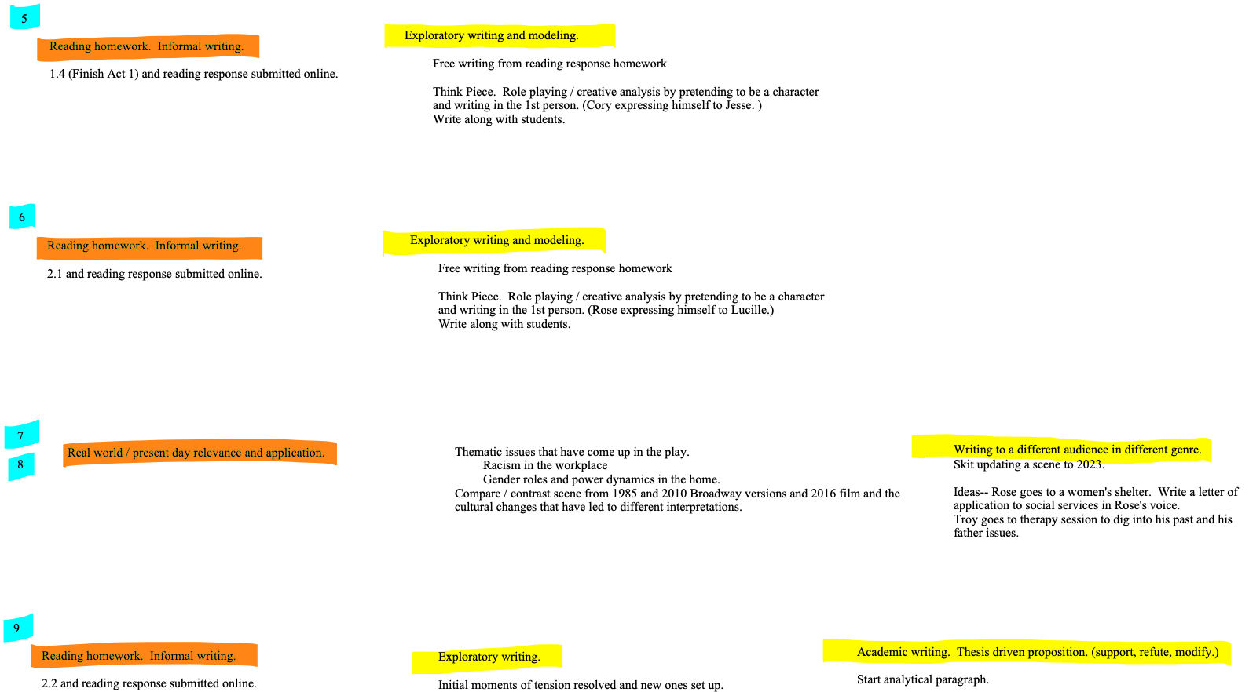
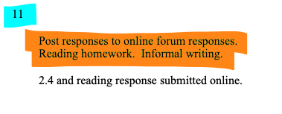
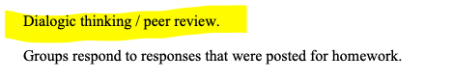
Deal with 2.4 somehow.

 | 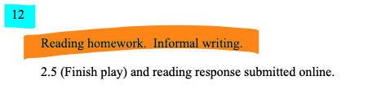
 |  |  |  |  | Deal with 2.5 somehow.
 |  |  | 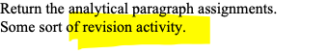 |  | Deal with 2.5 somehow.
